**Practical No:-11**

**Aim : Create a windows application to implement Simple & Parameterized Stored Procedure.**

**Code :**

**File name**:-Default.aspx

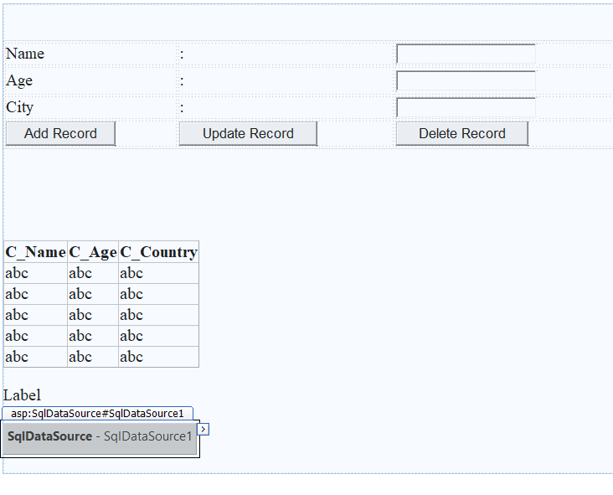

<%@ Page Language="C#" AutoEventWireup="true" CodeFile="Default.aspx.cs" Inherits="_Default" %>

<!DOCTYPE html>

<html xmlns="http://www.w3.org/1999/xhtml">

<head runat="server">

<title></title>

<style type="text/css">

.auto-style1 {

width: 57%;

}

.auto-style2 {

height: 33px;

}

</style>

</head>

<body>

<form id="form1" runat="server">

<div>

&nbsp;<br />

<br />

<table class="auto-style1">

<tr>

<td>Name</td>

<td>:</td>

<td>

<asp:TextBox ID="TextBox1" runat="server"></asp:TextBox>

</td>

</tr>

<tr>

<td class="auto-style2">Age</td>

<td class="auto-style2">:</td>

<td class="auto-style2">

<asp:TextBox ID="TextBox2" runat="server"></asp:TextBox>

</td>

</tr>

<tr>

<td>City</td>

<td>:</td>

<td>

<asp:TextBox ID="TextBox3" runat="server"></asp:TextBox>

</td>

</tr>

<tr>

<td><asp:Button ID="Button1" runat="server" OnClick="Button1_Click" Text="Add Record" /></td>

<td><asp:Button ID="Button2" runat="server" OnClick="Button2_Click" Text="Update Record" /></td>

<td><asp:Button ID="Button3" runat="server" OnClick="Button3_Click" Text="Delete Record" /></td>

</tr>

</table>

<br />

<br />

<br />

&nbsp;

&nbsp;

<br />

<br />

<asp:GridView ID="GridView1" runat="server" AutoGenerateColumns="False" DataSourceID="SqlDataSource1">

<Columns>

<asp:BoundField DataField="C_Name" HeaderText="C_Name" SortExpression="C_Name" />

<asp:BoundField DataField="C_Age" HeaderText="C_Age" SortExpression="C_Age" />

<asp:BoundField DataField="C_Country" HeaderText="C_Country" SortExpression="C_Country" />

</Columns>

</asp:GridView>

<br />

<asp:Label ID="Label1" runat="server" Text="Label"></asp:Label>

<br />

<br />

<asp:SqlDataSource ID="SqlDataSource1" runat="server" ConnectionString="<%$ ConnectionStrings:mcaConnectionString %>" SelectCommand="SELECT [C_Name], [C_Age], [C_Country] FROM [UserRegistration]"></asp:SqlDataSource>

<br />

</div>

</form>

</body>

</html>

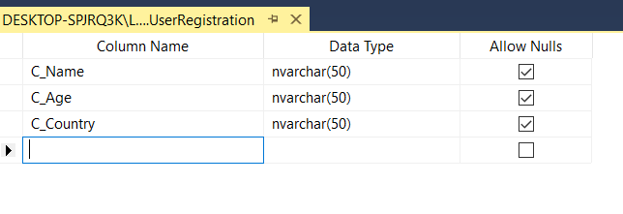

**Create your Stored Procedure**

Create PROCEDURE All_Operation_StoredProcedure(

@Name varchar(100)= null,

@Age varchar(100)= null,

@Country varchar(100)= null,

@Action varchar(100)= null

)

As begin

if @Action = 'Insert' Insert into UserRegistration(C_Name, C_Age,

C_Country) values(@Name, @Age, @Country)

if @Action = 'Update' Update UserRegistration set C_Name = @Name,

C_Age = @Age, C_Country = @Country where C_Name = @Name

if @Action= 'Delete' Delete from UserRegistration where C_Name =

@Name

End

**without parameter:**

Create PROCEDURE Select_Simple_StoredProcedure1

AS

begin

Select C_Name from UserRegistration

end

**Default .aspx.cs**

using System;

using System.Collections.Generic;

using System.Linq;

using System.Web;

using System.Web.UI;

using System.Web.UI.WebControls;

using System.Data;

using System.Data.SqlClient;

public partial class _Default : System.Web.UI.Page

{

protected void Page_Load(object sender, EventArgs e)

{

SqlConnection cn = new SqlConnection("Data Source=(LocalDB)\\MSSQLLocalDB;Initial Catalog=mca;Integrated Security=True");

SqlCommand cmd = new SqlCommand("Select_Simple_StoredProcedure1 ", cn);

cmd.CommandType = CommandType.StoredProcedure;

cn.Open();

SqlDataReader dr = cmd.ExecuteReader();

Label1.Text = " All users are: " ;

while (dr.Read())

Label1.Text += dr[0].ToString() + "\n " ;

dr.Close();

cn.Close();

}

protected void Button1_Click(object sender, EventArgs e)

{

SqlConnection cn = new SqlConnection("Data Source=(LocalDB)\\MSSQLLocalDB;Initial Catalog=mca;Integrated Security=True");

SqlCommand cmd = new SqlCommand("All_Operation_StoredProcedure", cn);

cmd.CommandType = CommandType.StoredProcedure;

cmd.Parameters.AddWithValue("@Action", "Insert");

cmd.Parameters.AddWithValue("@Name", TextBox1.Text);

cmd.Parameters.AddWithValue("@Age", TextBox2.Text);

cmd.Parameters.AddWithValue("@Country", TextBox3.Text);

cn.Open();

cmd.ExecuteNonQuery();

GridView1.Visible = true;

GridView1.DataBind();

cn.Close();

}

protected void Button2_Click(object sender, EventArgs e)

{

SqlConnection cn = new SqlConnection("Data Source=(LocalDB)\\MSSQLLocalDB;Initial Catalog=mca;Integrated Security=True");

SqlCommand cmd = new SqlCommand("All_Operation_StoredProcedure", cn);

cmd.CommandType = CommandType.StoredProcedure;

cmd.Parameters.AddWithValue("@Action", "Update");

cmd.Parameters.AddWithValue("@Name", TextBox1.Text);

cmd.Parameters.AddWithValue("@Age", TextBox2.Text);

cmd.Parameters.AddWithValue("@Country", TextBox3.Text);

cn.Open();

cmd.ExecuteNonQuery();

GridView1.Visible = true;

GridView1.DataBind();

cn.Close();

}

protected void Button3_Click(object sender, EventArgs e)

{

SqlConnection cn = new SqlConnection("Data Source=(LocalDB)\\MSSQLLocalDB;Initial Catalog=mca;Integrated Security=True");

SqlCommand cmd = new SqlCommand("All_Operation_StoredProcedure", cn);

cmd.CommandType = CommandType.StoredProcedure;

cmd.Parameters.AddWithValue("@Action", "Delete");

cmd.Parameters.AddWithValue("@Name", TextBox1.Text);

cmd.Parameters.AddWithValue("@Age", TextBox2.Text);

cmd.Parameters.AddWithValue("@Country", TextBox3.Text);

cn.Open();

cmd.ExecuteNonQuery();

GridView1.Visible = true;

GridView1.DataBind();

cn.Close();

}

}

**Output:-**

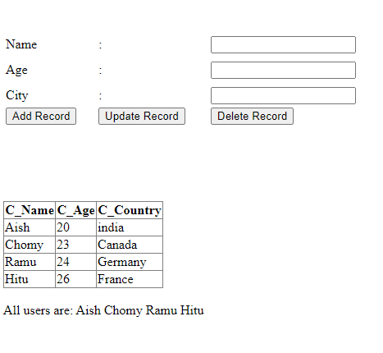

**Add Record:**

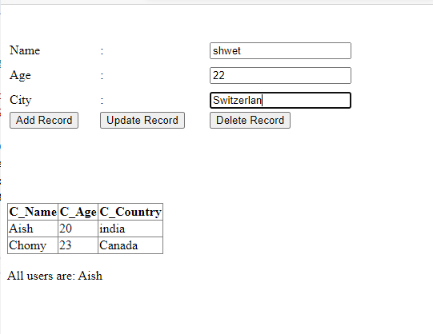

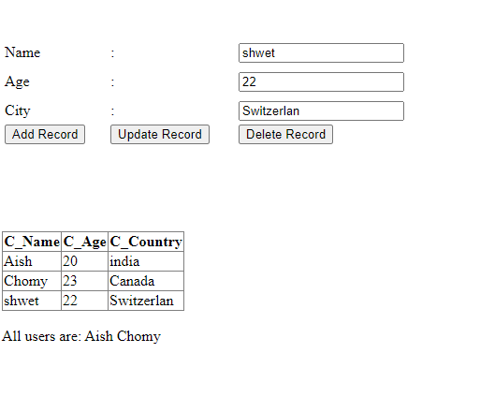

**Update Record:**

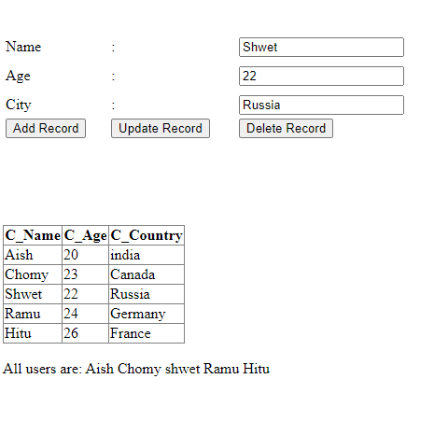

**Delete Record:**

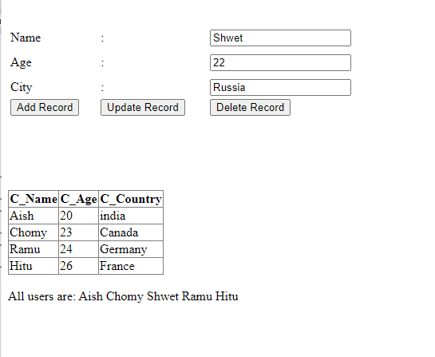

**Practical No:-12**

**Aim : .Create a windows applications on managing State: Client side (view state)**

**Code :**

File name:-view_state.aspx

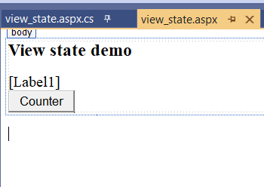

<%@ Page Language="C#" AutoEventWireup="true" CodeBehind="view_state.aspx.cs" Inherits="hidden_field_sm_.view_state" %>

<!DOCTYPE html>

<html xmlns="http://www.w3.org/1999/xhtml">

<head runat="server">

<title></title>

</head>

<body>

<form id="form1" runat="server">

<div>

<h3>View state demo</h3>

<asp:Label ID="Label1" runat="server" Text=""></asp:Label>

</br>

<asp:Button ID="Button1" runat="server" OnClick="Button1_Click" Text="Counter" />

</div>

</form>

</body>

</html>

File name:-view_state.aspx.cs

using System;

using System.Collections.Generic;

using System.Linq;

using System.Web;

using System.Web.UI;

using System.Web.UI.WebControls;

namespace hidden_field_sm_

{

public partial class view_state : System.Web.UI.Page

{

protected void Page_Load(object sender, EventArgs e)

{

}

protected void Button1_Click(object sender, EventArgs e)

{

int counter;

if (ViewState["Counter"] == null)

{

counter = 1;

}

else

{

counter = (int)ViewState["Counter"] + 1;

}

ViewState["Counter"] = counter;

Label1.Text = "Page Counter" + counter.ToString();

}

}

}

**Output:-**

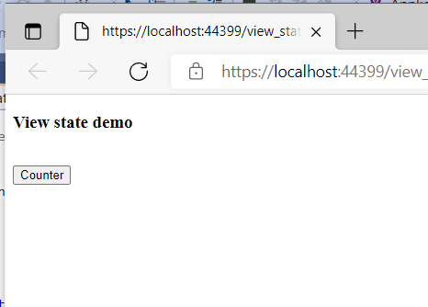

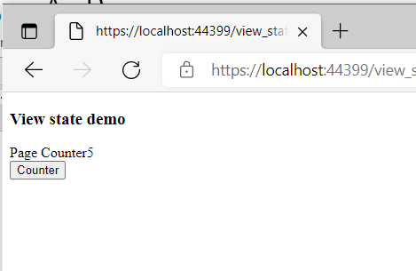

**Practical No:-13**

**Aim : Create a windows applications on managing State: Client side (Hidden field)**

**Code :**

File name:-WebForm1.aspx

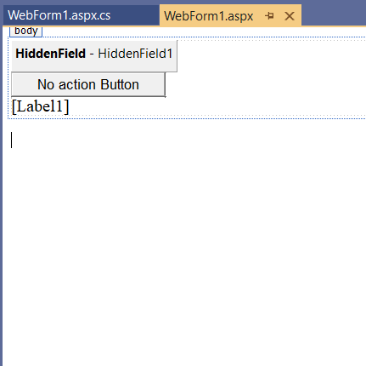

<%@ Page Language="C#" AutoEventWireup="true" CodeBehind="WebForm1.aspx.cs" Inherits="hidden_field_sm_.WebForm1" %>

<!DOCTYPE html>

<html xmlns="http://www.w3.org/1999/xhtml">

<head runat="server">

<title></title>

</head>

<body>

<form id="form1" runat="server">

<div>

<asp:HiddenField ID="HiddenField1" runat="server" Value="0" />

<asp:Button ID="Button1" runat="server" Text="No action Button" OnClick="Button1_Click" />

<br />

<asp:Label ID="Label1" runat="server" Text=""></asp:Label>

</div>

</form>

</body>

</html>

File name:-WebForm1.aspx.cs

using System;

using System.Collections.Generic;

using System.Linq;

using System.Web;

using System.Web.UI;

using System.Web.UI.WebControls;

namespace hidden_field_sm_

{

public partial class WebForm1 : System.Web.UI.Page

{

protected void Page_Load(object sender, EventArgs e)

{

if (HiddenField1.Value != null)

{

int val = Convert.ToInt32(HiddenField1.Value) + 1;

HiddenField1.Value = val.ToString();

Label1.Text = val.ToString();

}

}

protected void Button1_Click(object sender, EventArgs e)

{

}

}

}

**Output:-**

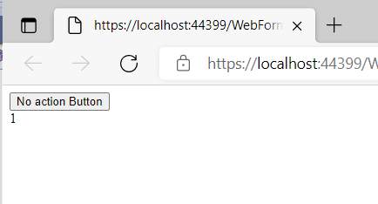

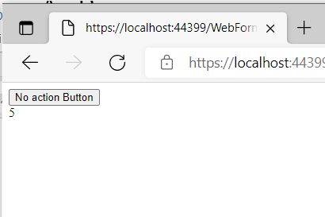

**Practical No:-14**

**Aim : .Create a windows applications on managing State: Client side (Persistent & Non Persistent Cookies)**

**Code :**

File name:-cookies.aspx

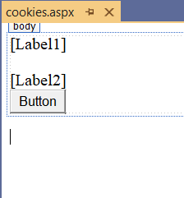

<%@ Page Language="C#" AutoEventWireup="true" CodeBehind="cookies.aspx.cs" Inherits="hidden_field_sm_.cookies" %>

<!DOCTYPE html>

<html xmlns="http://www.w3.org/1999/xhtml">

<head runat="server">

<title></title>

</head>

<body>

<form id="form1" runat="server">

<div>

<asp:Label ID="Label1" runat="server" Text=""></asp:Label><br />

<br />

<asp:Label ID="Label2" runat="server" Text="">

</asp:Label><br />

<asp:Button ID="Button1" runat="server" OnClick="Button1_Click" Text="Button" />

<br />

</div>

</form>

</body>

</html>

File name:-cookies.aspx.cs

using System;

using System.Collections.Generic;

using System.Linq;

using System.Web;

using System.Web.UI;

using System.Web.UI.WebControls;

namespace hidden_field_sm_

{

public partial class cookies : System.Web.UI.Page

{

protected void Page_Load(object sender, EventArgs e)

{

if (Request.Cookies["Persistance"] != null)

Label1.Text = Request.Cookies["Persistance"].Value;

else

Label1.Text = "";

if (Request.Cookies["NonPersistance"] != null)

Label2.Text = Request.Cookies["NonPersistance"].Value;

}

protected void Button1_Click(object sender, EventArgs e)

{

/*Persistent Cookies*/

HttpCookie aCookieValPer = new HttpCookie("Persistance");

aCookieValPer.Value = "This is A Persistance Cookie";

aCookieValPer.Expires = DateTime.Now.AddSeconds(10);

Response.Cookies.Add(aCookieValPer);

/*Non Persistent Cookies*/

HttpCookie aCookieValNonPer = new HttpCookie("NonPersistance");

aCookieValNonPer.Value = "This is A Non Persistance Cookie";

Response.Cookies.Add(aCookieValNonPer);

}

}

}

**Output:-**

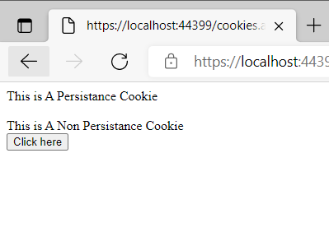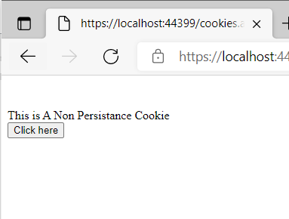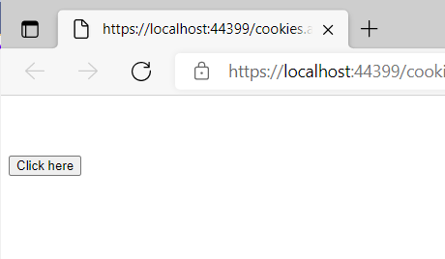

**Practical No:-15**

**Aim : Create a windows applications on managing State: Server Side(Session Management)**

**Code :**

File name:-session.aspx

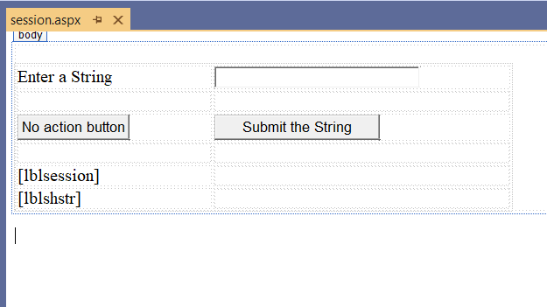

<%@ Page Language="C#" AutoEventWireup="true" CodeBehind="session.aspx.cs" Inherits="hidden_field_sm_.session" %>

<!DOCTYPE html>

<html xmlns="http://www.w3.org/1999/xhtml">

<head runat="server">

<title></title>

</head>

<body>

<form id="form1" runat="server">

<div>

&nbsp; &nbsp; &nbsp;

<table style="width: 568px; height: 103px">

<tr>

<td style="width: 209px">

<asp:Label ID="lblstr" runat="server" Text="Enter a String"

style="width:94px">

</asp:Label>

</td>

<td style="width: 317px">

<asp:TextBox ID="txtstr" runat="server" style="width:227px">

</asp:TextBox>

</td>

</tr>

<tr>

<td style="width: 209px"> </td>

<td style="width: 317px"> </td>

</tr>

<tr>

<td style="width: 209px">

<asp:Button ID="btnnrm" runat="server"

Text="No action button" style="width:128px" />

</td>

<td style="width: 317px">

<asp:Button ID="btnstr" runat="server"

OnClick="btnstr_Click" Text="Submit the String" />

</td>

</tr>

<tr>

<td style="width: 209px"> </td>

<td style="width: 317px"> </td>

</tr>

<tr>

<td style="width: 209px">

<asp:Label ID="lblsession" runat="server" style="width:231px" >

</asp:Label>

</td>

<td style="width: 317px"> </td>

</tr>

<tr>

<td style="width: 209px">

<asp:Label ID="lblshstr" runat="server">

</asp:Label>

</td>

<td style="width: 317px"> </td>

</tr>

</table>

</div>

</form>

</body>

</html>

File name:-session.aspx.cs

using System;

using System.Collections.Generic;

using System.Linq;

using System.Web;

using System.Web.UI;

using System.Web.UI.WebControls;

namespace hidden_field_sm_

{

public partial class session : System.Web.UI.Page

{

String mystr;

protected void Page_Load(object sender, EventArgs e)

{

}

protected void btnstr_Click(object sender, EventArgs e)

{

this.mystr = this.txtstr.Text;

this.Session["str"] = this.txtstr.Text;

this.lblshstr.Text = this.mystr;

this.lblsession.Text = (String)this.Session["str"];

}

}

}

**Output:-**

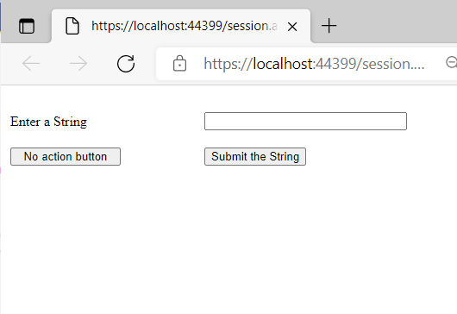

[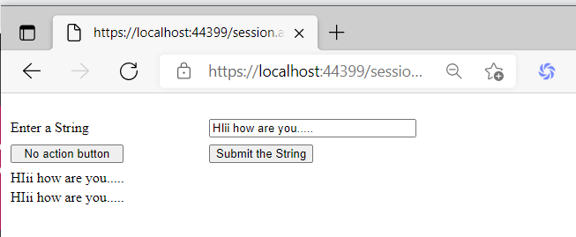](https://drive.google.com/file/d/18iabSqyxlgtnWKVfatOTSkxKMPXtnk15/view?usp=drive_web&authuser=1)